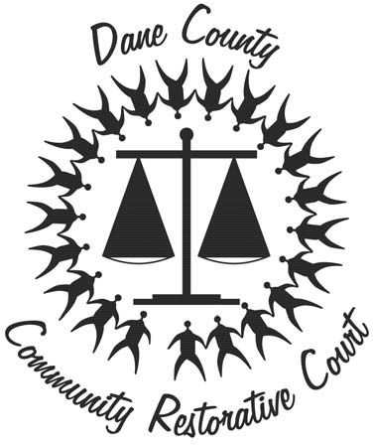
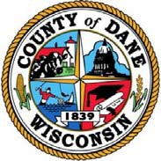
RESTORATIVE JUSTICE

Community Restorative Court

Restorative Justice
is an approach that focuses on the needs of the victims, respondents, and the aﬀected community. Victims can actively participate in the process, while respondents acknowledge re‐ sponsibility for their actions.
The goals of restorative justice are to repair harm, reduce the risk of re‐oﬀense and rebuild community.

Our Restorative Justice program is modeled after the processes utilized by
Native American tribes for generations.

“Circle Justice” involves resi‐ dents, victims, and respondents working together to find resolu‐ tion and repair harm done to communities by crime.
818 W Badger Rd, Madison WI 53713

(Vacant)
Coordinator
Phone: (608) 630-1214
Johnson-hs.ronald@countyofdane.com

Stephanie Marino
Senior Social Worker Phone: (608) 283-1683
marino@countyofdane.com

Donnetta Foxx
Program Leader
Phone: (608) 283-1686
foxx.donnetta@countyofdane.com

Jackie Hammond
Program Leader Phone: (608) 977-4519
hammond.jackie@countyofdane.com

Our Partners:
Dane County Department of Human Services Dane County District Attorney’s Oﬃce
Dane County Sheriﬀ’s Oﬃce City of Madison Police Department
Law Enforcement Agencies throughout Dane County UW Madison Law School Restorative Justice Project
Dane County Subcommittee on Racial Disparities in the Criminal Justice System
Center for Court Innovation

Dane County Community Restorative Court
REP A IR HARM REDUCE RISK
REBUILD COM M UNITY

A Restorative Justice alternative for
17-25 year-olds with misdemeanor offenses or municipal citations

Dane County Community Restorative Court (CRC)
June 2020

Why the CRC?

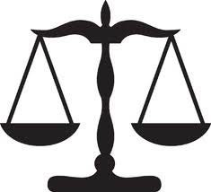
The CRC is an innova- tive way to expedite misdemeanor cases and provide an alter- native to the tradi- tional justice system.
This approach holds respondents responsible, often with community service and restitution. It also provides human services sup-
port when appropriate. Victims are given a voice and community participation is essential. Respondents do not have a CCAP entry and receive no formal charge if they complete their repair harm agree- ment successfully. This collaborative ap- proach to community justice was launched in south Madison in the Spring of 2015 after years of research and extensive engagement with the community under the leadership of Dane County’s Subcommit- tee on Racial Disparities.
The Mission of the CRC is to:

REPAIR HARM REDUCE RISK REBUILD COMMUNITY
The CRC response to crime is victim- based, respondent-focused, and community-driven.

Who is the focus of CRC?
The CRC is designed for young people 17-25 years old who have committed a misdemeanor crime or have received a municipal citation in Dane County. Some eligible misdemeanors and citations include:

- Simple battery
- Disorderly Conduct
- Obstructing an Officer
- Theft

- Criminal Damage to Property

What is the Process?
A respondent is offered the opportunity to participate in the CRC if eligible and referred by a criminal justice partner. The respondent has to accept responsibility for their actions and be willing to participate in the restorative justice process.
The CRC staff are not officers of the law, but rather facilitators of a Restorative Justice process. The CRC staff meet with both victim and respondent separately to discuss the incident. The respondent, victim, and Peacemakers (trained volunteers from the community) meet in the circle process to create an agreement outlining steps the respondent will take to repair the harm.

Is Restorative Justice Effective?
Studies indicate Restorative Justice processes in comparison to the traditional criminal justice system:

- Resolve cases more quickly;
- Result in a higher percentage of offenders making full restitution payments;
- Generate greater satisfaction and feelings of fairness on the part of both victims and offenders with regard to the handling and outcomes of a case;
- Reduce recidivism; and
- Demonstrate significant cost per case savings. *

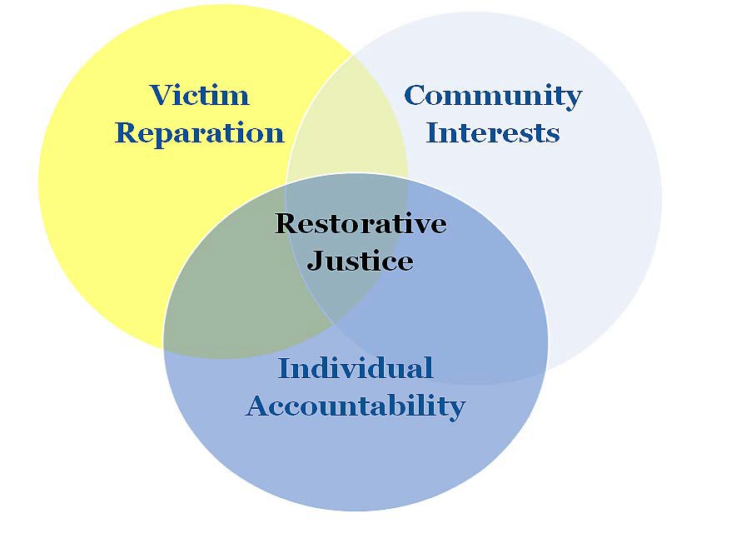

*Evidence-based Research Analysis on the Effectiveness of Restorative Justice, Jonathan Scharrer, Director, Restorative Justice Project, University of Wisconsin Law School

