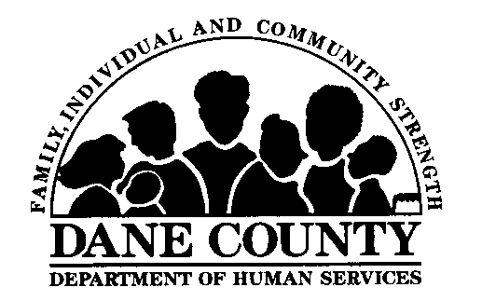 |  | Dane County Department of Human Services  Division of Children, Youth & Families  1202 Northport Dr. Madison WI 53704
Director – Shawn Tessmann
Division Administrator – Connie Bettin
JOE PARISI
DANE COUNTY EXECUTIVE

Dear Kinship Care Applicant:

Kinship Care is a payment resource that provides a monthly grant of $254.00 to eligible relatives caring for relative children. This benefit is funded with Federal Temporary Assistance for Needy Families (TANF) monies, although, Wisconsin’s Kinship Care program is not income-based.

Kinship Care application forms are enclosed. The packet includes a prepaid addressed return envelope for your convenience.

Some of the required documentation will include:

- Relationship Verification- Applicants are responsible for providing copies of documents that show the relationship between applicant and relative child. Examples include birth certificates, paternity documents, marriage licenses or family obituaries.
- Background Information Disclosure Forms- Each adult member of the household must complete a form.
- Verification of Residence- Applicants must show documentation the relative child resides with them. Examples may include child’s school registration paperwork with relative’s address listed, copy of guardianship or court order, a statement from the child’s parent granting permission for placement.
- Verification of Health Insurance- If the relative child has private health coverage please provide proof of coverage. If the child has Badgercare health coverage we will access that documentation through our own systems.

You may be eligible for Foodshare, Badgercare or Wisconsin Shares Childcare Assistance and can apply for those benefits by calling Capital Consortium 1-888-794-5556 or online at access.wisconsin.gov. If you are determined to be eligible for a Kinship Care payment you are expected to cooperate with the referral of the child’s parents to the child support agency.

If you have any questions regarding Kinship Care forms, documentation or eligibility requirements please contact us. We are here to assist you.

Sarah Kasel Carolyn Fatsis
DCDHS Kinship Care DCDHS Kinship Care
(608) 242-6381 (608) 242-6308
(608) 335-0074 (608) 320-5714
Kasel@countyofdane.com fatsis@countyofdane.com

KINSHIP CARE APPLICATION CHECKLIST

- Kinship Care Payment Application-please sign page 10

- Additional Kinship Care Child form (if applicable)

- Background Information Disclosure Form (one per adult member of household)

- Relationship Verification documents

- Verification of Residence documents

- Verification of private health insurance (if applicable)

- Copy of guardianship order (if applicable)

